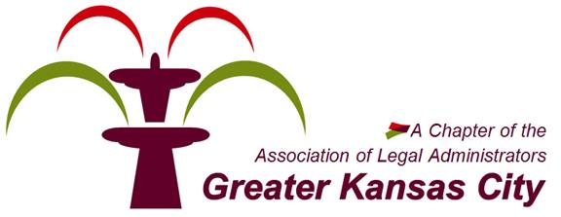
KCALA PRESENTS
THE ANNUAL
BUSINESS PARTNER
NETWORKING EVENT
September 24, 2015 4:30 to 6:30pm
THE BRASS ON BALTIMORE
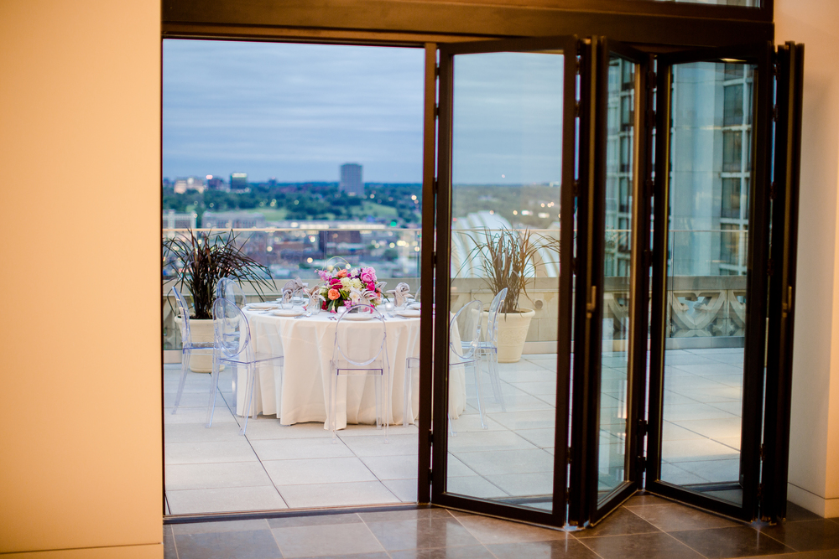
1228 Baltimore Ave., Kansas City, Missouri 64105
RSVP to sarah.cramer@bryancave.com

