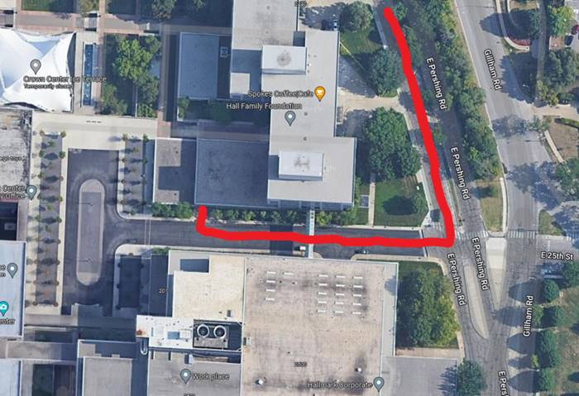

Coming from Grand Blvd or Main Street:
- Take E. Pershing Road south (opposite direction of Union Station)
- Turn Right on E 25th Street (there will be a red sign on the SW corner of the intersection that says “Kaleidoscope” and a blue sign that says “Hallmark Visitors Center”)

- 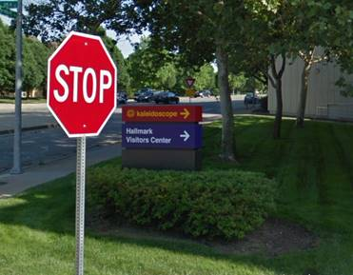

- Turn right into parking garage labeled “Interview Parking”

- 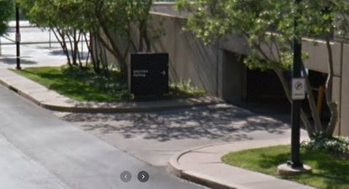

- Elevators will be at the back, right of the garage. I recommend you park near the elevators, but do not park in a “reserved” spot.

